Restore db

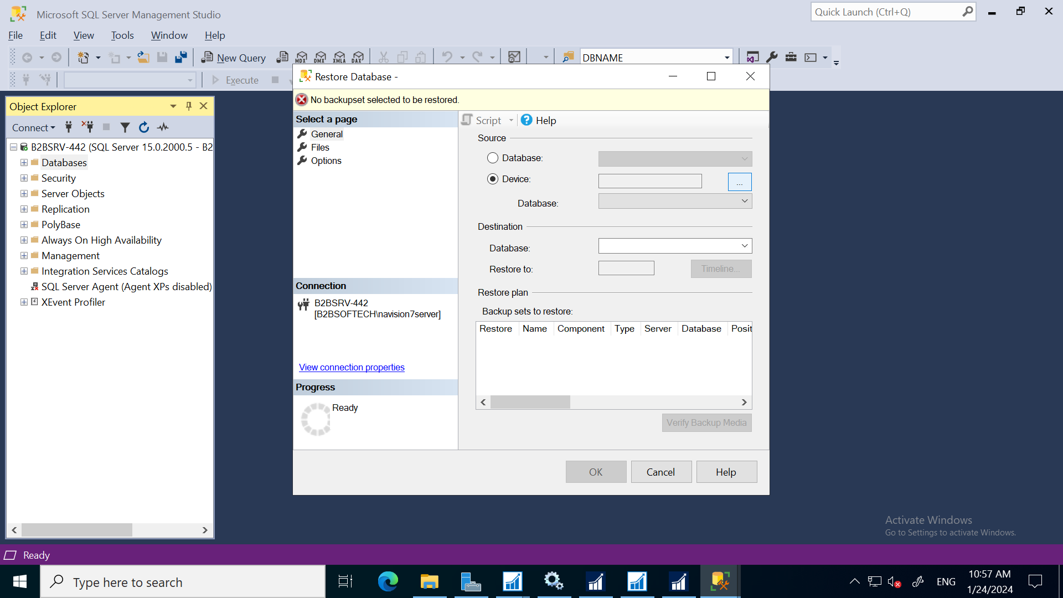

Above is faied so disable option in “Tail log Backup”options tab as below

